A1342-ME-Syro-Hittite-Astarte-Figurine-Terracotta-Late Bronze Age-1500 - 1200 BCE

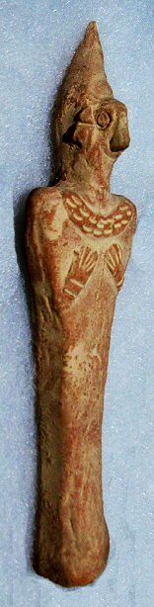 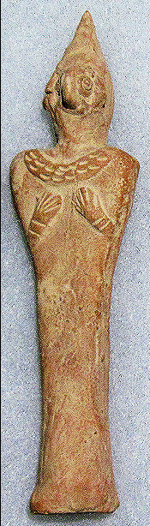 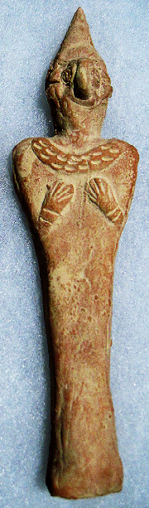 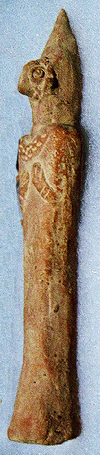

**Case no.: 3**

**Accession Number: A1342**

**Formal Label:** Syro-Hittite-Astarte-Figurine-Terracotta-Late Bronze Age-1500 - 1200 BCE **Display Description:**

This stylized figurine with flat violin-shaped body and bird face with elaborate coiffure has two short arms pressed against the breasts. A very faint navel in the lower abdomen area. Incised design decorates the torque around the neck (cf. Spycket, A., Borowski Collection, 2000, Cat. no. 84, p. 102, (photograph, p. 101), for the type with long arms; Keel, O., Freiburg, 2008, p. 23, fig 3).

**LC Classification:**

**Date or Time Horizon:** Late Bronze Age-1500 - 1200 BCE

**Geographical Area:**

**Map, GPS coordinates:**

**Cultural Affiliation:** Syro-Hittite

**Medium:** Terracotta

**Dimensions:** H. 13.4 cm., 5 1/4 in

**Weight:**

**Condition:** Syro-Hittite

**Provenance:** Ex. Private collection 1980's; Gideon Sasson, Sasson Ancient Art, King David Hotel - Annex, Jerusalem - 94101, Israel.

Discussion:

**References:**

Keel, O. 2008. *Gott weiblich: Eine verborgene Seite des biblischen Gottes, Gutersloher Verlagshaus*. Freiburg.

Spycket, A. 2000. *The Human Form Divine. From the Collection of Elie Borowski,* Exh. cat., Jerusalem: Bible Lands Museum.